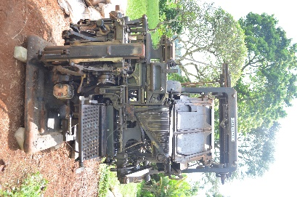 | INTERTYPE: was mostly used during the budgeting period because of its speed.  manufactured between 1912 and 1976
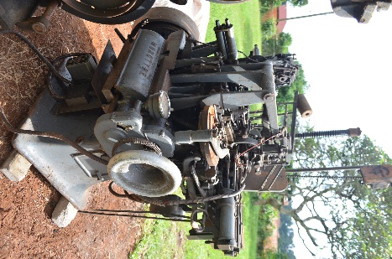 | MONOTYPE: Was used mostly in printing of books.  The first Monotype typesetting machine was invented by American engineer Tolbert Lanston, who patented his initial mechanical typesetting device in 1887. The commercial hot-metal system, featuring the keyboard and the casting machine, was brought to market in 1900
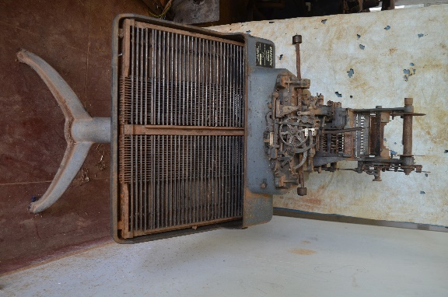 | MONOTYPE-CASTER: Was mostly used during finance bill which had lots of figures.  Between 1900 and the late 1960s. Tolbert Lanston’s Monotype system—consisting of a perforated paper-tape Keyboard and an automatic hot-metal Caster—was first brought to commercial market in 1900. Production of these machines steadily continued until the last Caster was manufactured in Surrey, England, in 1989
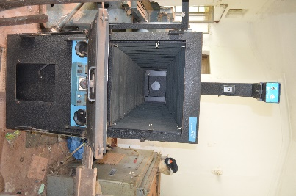 | CAMERA: Was majorly used for image transfer and processing.
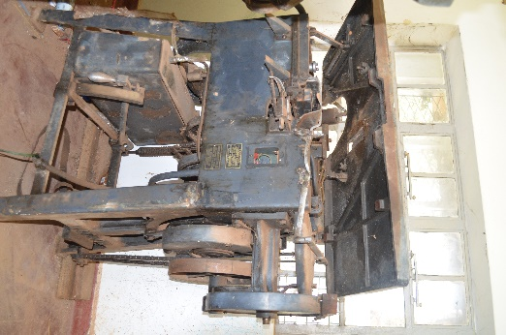 | LUDLOW PHOTOGRAPH MACHINE: It was designed to type big letters suitable for posters, letterheads, IDs etc  The Ludlow Typograph was manufactured starting in 1912. First developed commercially in 1911, the hot metal typesetting machine was invented by William I. Ludlow and William A. Reade. Commercial production began in Chicago, and the machine found its way into printing plants around 1913 to 1914
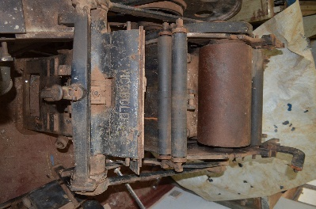 | VICOBOLD: It was used to for relief printing, embossing, debossing, and foil stamping.  Was manufactured from the mid-1920s through the 1950s. The presses were originally designed and built in Germany by Rockstroh-Werke AG around 1925, and were later manufactured under license in the UK by Frank F. Pershke
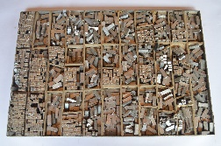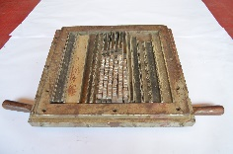  Letter blocks  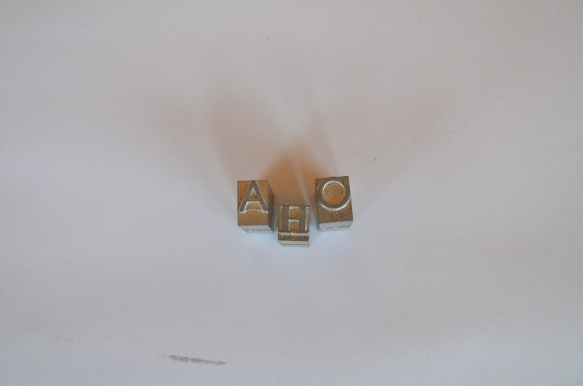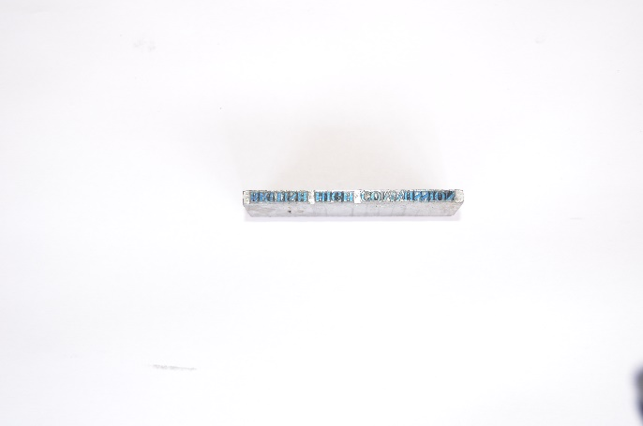 | LETTER BLOCKS: they are majorly into two types i.e single block and the Slag which are casted by the monotype machine and intertype machine respectively.

NB. The use of these machines at UPPC is estimated to be from 1920s

